Tool 6.1b: SPPB FAME SAMPLE

Section in Planner: Phase 2, Step 6 (6.1b); activate Step 8
Why is this important?
An understanding of program and participant outcomes is fundamental to establishing program sustainability. Best practices for the evaluation of post-stroke community-based exercise programs include a variety of measurement strategies. Many are described in the guide.
How to use this tool:
The indicators you choose should be meaningful to your stakeholders, i.e. participants want to know how they are doing, and administrators want to know if they should continue to support delivery of the program. Your evaluation plan should also consider what is practical to be administered effectively in your setting and how any participant information collected will be managed.
The Short Physical Performance Battery (SPPB), from the FAME* exercise program is one example of a participant evaluation. Instructions for administration are included with the tool. Further information is available from FAME.

*FAME. FAME – fitness and mobility exercise program. 2020 [cited 2020 Apr 10]. Available from: http://fameexercise.com/

Phase 3, Step 8: Short Physical Performance Battery (SPPB) – FAME SAMPLE
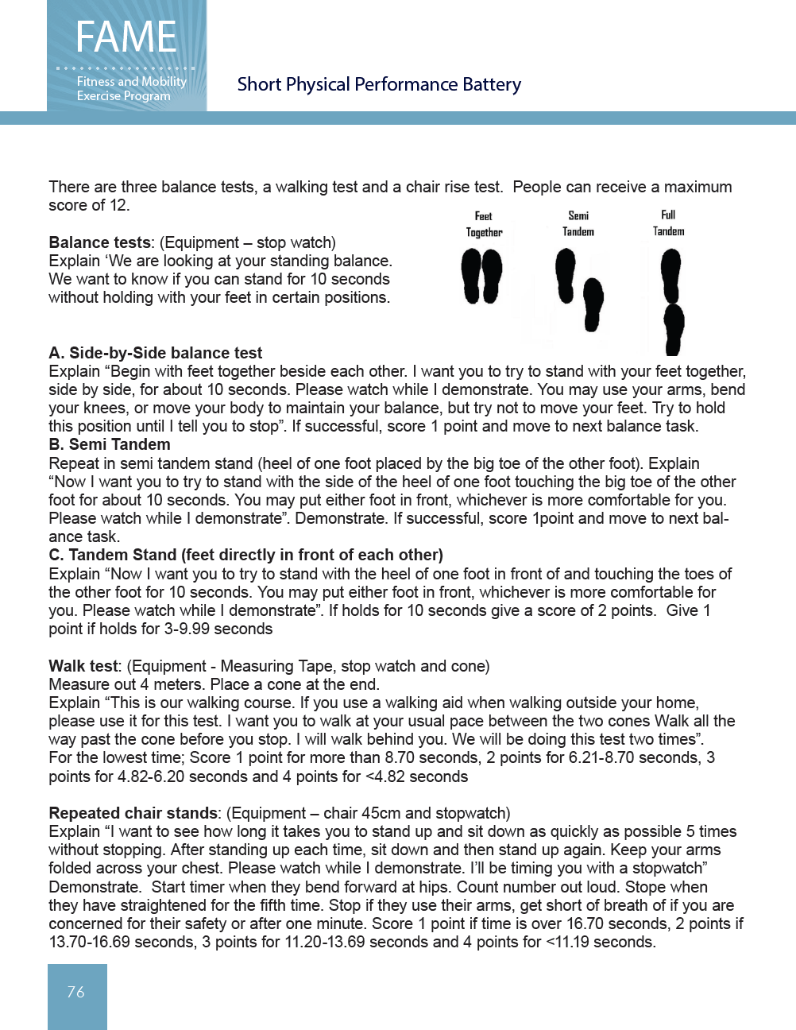

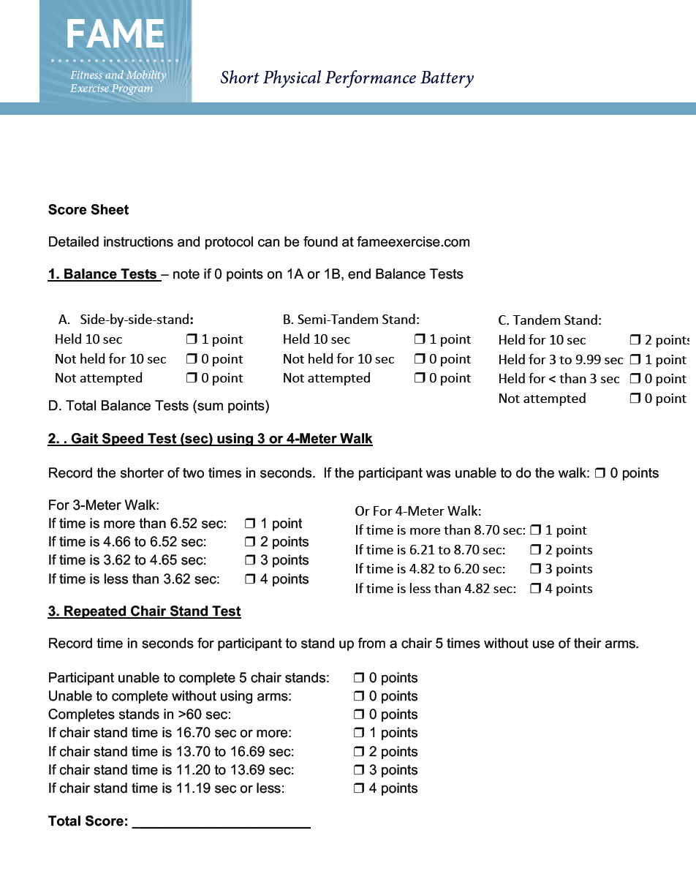
Below is a sample one-page feedback form that can be provided to participants and is derived from the Short Physical Performance Battery.
Name: Date
Balance assessments
 | Held for seconds
 | Held for seconds
 | Held for seconds
Walking assessment
 | 4 Metres in seconds
Chair stand assessment
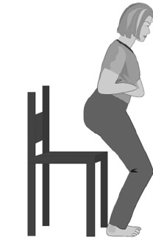 | 5 Chair stands in seconds

